第八届中国北京国际文化创意产业博览会
The 8th China Beijing International Cultural & Creative Industry Expo

促进文化贸易 加快经济升级

中国国际展览中心
China International Exhibition Center
2013年11月7-10日
November 7-10, 2013

前言 PREFACE
文化创意产业
在全球的兴起标志着一个新的时代的来临，随着经济全球化趋势的加快和科技水平的提高，文化创意产业呈现出前所未有的发展前景。据统计，全世界文化创意产业每天创造的产值达220亿美元，并以5%左右的速度递增。文化创意产业正在成为21世纪全球最具有商业价值和文化内涵的朝阳产业。
北京
作为中国的文化中心，文化底蕴深厚，资源人才优势明显，发展文化创意产业得天独厚。北京已将文化创意产业作为未来经济发展的重要支柱之一，进行重点扶持和发展。按照规划，北京市将重点建设中国八大文化创意产业中心，即：全国文艺演出中心，出版发行和版权贸易中心，影视节目制作和交易中心，动漫和网络游戏研发制作中心，广告会展中心，古玩艺术品交易中心，设计创意中心文化旅游中心。
中国北京国际文化创意产业博览会（简称“文博会”）
中国北京国际文化创意产业博览会是经国务院批准，由文化部、国家新闻出版广电总局和北京市政府共同主办，北京市委宣传部等26个委办局协办，北京市贸促会承办的大型国际文化创意产业盛会。文博会坚持贯彻中央关于发展文化创意产业的有关精神，秉承国际化、专业化、市场化、规范化、精品化的办会办展理念，全面展示国内文化创意产业发展的丰硕成果，交流当今世界的文化创意产业发展的最新理论和观点，搭建文化产品、文化服务的交易平台，在推动文化创意产业化、促进文化创意产业国际投资合作与文化贸易方面发挥着重要的作用。
文博会每年下半年在北京举办，自2006年创办以来，迄今已成功举办七届，据不完全统计，前七届文博会共吸引了来自联合国、欧盟、世界知识产权组织、国际工业设计联合会等20多个国际组织高层官员、各国文化创意产业主管部门负责人及国内外知名专家、学者和企业家等1055人应邀发表演讲；近90个国家和地区的190余个代表团以及来自中国31个省区市的80多个代表团参加了展览展示、论坛峰会、推介交易等板块的活动；签署合作意向、协议1340个，总金额233.1亿美元。
第八届中国北京国际文化创意产业博览会
将于2013年11月7日—10日在北京举办。第八届文博会将通过展览展示、创意活动、推介交易和论坛峰会等活动，吸引国内外文化创意的高端技术和产品，搭建一个文化创意产业信息交流、产品交易和项目合作的重要平台，为文化创意产品的市场化、产业化和国际化提供广阔的发展空间；打造成为融创意思维、科技含量、文化底蕴于一体的世界性文化创意盛会。
Cultural & Creative Industry
The spring of the Cultural & Creative Industry all over the world is the symbol of a new era. With picking up the trend of global economy and improving the level of science & technology, Cultural & Creative Industry is appearing unprecedented developing prospect. According to statistic, production value of Cultural & Creative Industry in the world is USD 22 Billion per day; meanwhile it is increasing by 5% rate. Cultural & Creative Industry is going to be the rising sun industry that is the top of business value and cultural connotation in 21century.
Beijing
As the center of culture of China, Beijing owns profound cultural inner strength and obvious advantages of resource and talent, so that Beijing has condition of abounding in gifts of nature to develop Cultural & Creative Industry. Beijing has definitely put forward the Cultural & Creative Industry as one of the most important pillar at capital economy development in the future. According to the development plan, Beijing will build up centers of Chinese Cultural & Creative industry in eight areas. They are center of literature and performance, trade center of publication and copyright, producing program and trade center of film and television, developing and producing center of animation and game, center of advertisement and exhibition, trade center of curio and arts, center of design and creativity, and center of culture and tourism.
China Beijing International Cultural & Creative Industries Expo (ICCIE)
China Beijing International Cultural & Creative Industries Expo (ICCIE) is a large-scale international gathering of the cultural and creative industries approved by the PRC State Council, co-hosted by the PRC Ministry of Culture, the PRC State Administration of Radio, Film and Television (SARFT), the PRC General Administration of Press and Publication (GAPP) and the People’s Government of Beijing Municipality, supported by 26 departments including the Publicity Department of the Party Committee of the People’s Government of Beijing Municipality, and organized by the China Council for the Promotion of International Trade (CCPIT) Beijing Sub-council. In line with the Chinese government’s commitment to booming the cultural and creative industries and according to the principles of organizing high-quality international conferences and exhibitions via standard, professional and market-oriented approaches, ICCIE displays rich development fruits of Chinese cultural and creative industries on all fronts, exchanges latest international theories and viewpoints on development of cultural and creative industries, builds up platforms for trading of cultural products and services and thereby plays an important role in promoting industrialization of the cultural and creative sectors and facilitating international trade and investment cooperation related to the cultural and creative industries.
ICCIE is an annual event taking place during the latter half of the year. Since 2006, the year of its initiation, 7 ICCIEs have been successfully held. According to incomplete statistics, the 7 ICCIEs attracted 1055 speakers including high-level officials from over 20 international organizations such as United Nation, the European Union, the World Intellectual Property Organization and the International Council of Societies of Industrial Design, heads of national authorities in charge of cultural and creative industries as well as well-known experts, scholars and entrepreneurs from home and abroad. Over 190 delegations from nearly 90 countries and regions and more than 80 delegations from 31 Chinese provinces and trade fairs of the 5 ICCIEs where 1340 letters of intention and formal agreements for cooperation were signed involving a total amount of USD23.31 billion.
The 8th Session of ICCIE
The 8th Session of ICCIE will be held on Nov.7-10, 2013 in Beijing. It will continue to attract domestic and foreign cuspidate technology and production of culture & creation to build a platform for intercommunications of cultural & creative information, transactions of productions and cooperations of items, provide widely space for cultural & creative production’s marketization, industrialization and internationalization; it will be built a international cultural & creative pageant including creative thought, technical continent and cultural details.
组织机构 THE ORGANIZING COMMITTEE OF ICCIE
主办单位
中华人民共和国文化部
中华人民共和国国家新闻出版广电总局
北京市人民政府
HOSTS
The Ministry of Culture, P. R. C
The State Administration of Press Publication, Radio, Film and Television, P. R. C
The People’s Government of Beijing Municipality
承办单位
中国国际贸易促进委员会北京市分会
ORGANIZER
China Council for the Promotion of International Trade Beijing Sub-councill
协办单位
中共北京市委办公厅
中共北京市委宣传部
中共北京市委统战部
中共北京市委教育工作委员会
北京市人民政府办公厅
北京市发展和改革委员会
北京市科学技术委员会
北京市经济和信息化委员会
北京市公安局
北京市财政局
北京市规划委员会
北京市市政市容管理委员会
北京市商务委员会
北京市旅游发展委员会
北京市文化局
北京市国有文化资产监督管理办公室
北京市卫生局
北京市人民政府外事办公室
北京市工商行政管理局
北京市广播电影电视局
北京市新闻出版局（北京市版权局）
北京市文物局
北京市体育局
北京市知识产权局
北京市人民政府台湾事务办公室
共青团北京市委
中关村科技园管理委员会
北京市文化创意产业促进中心
CO-ORGANIZERS
The General Office of Beijing Municipal Committee of CPC
Publicity Department Beijing Municipal Committee of CPC
The United Front Work Department of CPC Beijing Committee
Beijing Municipal Committee of Education of CPC
The General Office of the Beijing Municipal People’s Government
Beijing Municipal Commission of Development and Reform
Beijing Municipal Commission of Science and Technology
Beijing Municipal Commission of Economy and Information Technology
Beijing Municipal Bureau of Public Security
Beijing Municipal Bureau of Finance
Beijing Municipal Commission of Urban Planning
Beijing Municipal Administration Commission
Beijing Municipal Commission of Commerce
Beijing Municipal Commission of Tourism Development
Beijing Municipal Bureau of Culture
State-owned Cultural Assets Supervision and Administration Office of the
People's Government of Beijing Municipality
Beijing Municipal Health Bureau
Foreign Affairs Office of the People’s Government of Beijing Municipality
Beijing Administration for Industry and Commerce
Beijing Municipal Bureau of Radio, Film and Television
Beijing Municipal Bureau of Press and Publication (Beijing Municipal
Bureau of Copyright)
Beijing Municipal Administration of Cultural Heritage
Beijing Municipal Bureau of Sport
Beijing Intellectual Property
Taiwan Affairs Office of the Beijing Municipal Government
China Communist Youth League Beijing Committee
Zhongguancun Science Park Administration Committee
Beijing Cultural and Creative Industry Promotion Center
主要活动内容 CONTENT OF ICCIE
1、展览展示
汇集国内外优秀的文化创意产业的组织机构、企事业单位，从文化创意产业集聚区、广播电影电视、新闻出版和版权贸易、设计创意、文物与博物馆、动漫游戏、旅游商品与文化旅游景区、体育产业、画廊与艺术品、创意礼品、城市雕塑等方面进行全方位的展示。充分展现文化创意产业优秀企业和通过创意、科技、文化的完美结合所形成的文化创意成果和产品，成为了解国内外文化创意产业产品与信息的最佳展示平台。
I. Exhibition:
Gathering outstanding organizations and enterprises at home and overseas from 11 aspects:
1. Gathering districts and center of cultural & creative industry
2. Broadcasting, film and television
3. Press, publication, printing and copyright trade
4. Cultural and art performance industry
5. Software, animation and game
6. Advertising and exposition design
7. Cultural tourist attraction and commodity
8. Creative design
9. Painting and calligraphy
10. Industrial arts and crafts
11. Public sculpture
The exhibition will be showing outstanding enterprises of Cultural & Creative industry, achievements and production by creativity, science & technology and culture unite together perfectly. Meanwhile, it will be the most excellent platform via understanding production and information at home and overseas.
2、论坛会议
立足全球视野探讨文化创意产业发展方向，点面结合，探讨促进北京以及全国文化创意产业与世界各国的有效对接的高层论坛，通过文化创意产业资源整合，带动我国文化创意产业结合的调整与升级。
II. Forums and Conference
It will be the main forum - International Forum on Cultural & Creative Industry Development, and a number of subforums: Intellectual Property Protection & Copyright Trade Forum, Film & Television Development Forum, Software Development & Network Game Industry Forum, Advertisement Design and Creativity Forum and so on.
It will be a high-level forum, discussing development prospect of Cultural & Creative industry at global view, studying effective link Cultural & Creative industry between Beijing and foreign countries.
3、推介交易
从文化创意产业基地招商、版权交易、文化演出节目交易、动漫游戏和软件开发、艺术品拍卖等方面进行专业推介交易，结合行业的特点，注重交易实效，打造文化创意产业经贸交流的最有效渠道。
III. Presentations and Trade Fairs
It will set up the most effective trade channel for Cultural & Creative Industry via looking for clients in Cultural &
Creative Industry Zones; professional promotion from copyright trade, performances trade, tourism services trade, animation, game, software developing and art auction with industry characteristic and trade effect.
4、创意活动
从文化创意、动漫游戏、书画艺术、文物鉴赏等多角度进行展播、评选、合作与交流，鼓励创作更多更好的创意作品，从而促进文化创意产业的发展。
IV. Creative Activities
It will be showing, selecting, choosing, cooperating and exchanging from Culture & Creativity, animation, game, painting & calligraphy and cultural relic appreciation and authentications, and promoting development of Cultural & Creative industry.
展览内容 EXHIBITION PROFILE
1-1A馆
文化演艺与动漫游戏展区
1、动漫游戏及相关影视、互联网娱乐产品
2、舞台艺术
3、非遗艺术品
4、数字图书馆
Hall 1-1A
Animation & Game, Stage Arts, Intangible Cultural Heritage, Digital Library Exhibition
1. The animation, cartoon & game and relative products from film, TV and entertainments
2. Stage arts
3. Intangible cultural heritage
4. Digital library
1-1B馆
广播电影电视展区
1、广播电影电视内容服务及节目制作机构
2、广播电影电视设备及技术
3、广播电影电视网络运营机构
4、广播电视播出机构及新兴媒体
5、广播电视节目、影视剧、影视动画片
6、数字电影、数字电视、移动多媒体广播
Hall 1-1B
Broadcasting, Film & Television Exhibition
1. Content service & program production organizations of radio, film and TV
2. Equipments and technologies of radio, film and TV
3. Network operation organizations of radio, film and TV
4. Mass media organizations & new media
5. Radio, TV program, teleplay and cartoon of film & TV
6. Digital film, TV and mobile mass media radio
1-2A馆
台湾文创精品展区
1、创意民俗工艺
2、创意设计
3、数字内容及动漫等
Hall 1-2A
Taiwan Cultural & Creative Industry Exhibition
1. Creative folk crafts
2. Creative design
3. Digital contents & animation
1-2B馆
文物及博物馆相关文化创意产品展区
1、文物及古玩艺术品
2、博物馆
3、博物馆相关的展陈设计装饰
4、博物馆相关的动漫设计
Hall 1-2B
Cultural Relics & Museum Related Creative Products Exhibition
1. Cultural relics and curio arts
2. Museums
3. Design and decoration of museum display
4. Animation design in museums
2号馆
工艺美术展区
工艺美术精品展示
Hall 2
Arts and Crafts Exhibition
Arts and crafts works
3-4号馆
文化创意产业集聚区展区
1、文化创意产业集聚区展示
2、文化创意产业基地及产业园区展示
Hall 3-4
Cultural & Creative Industry Gathering Cluster Zone Exhibition
1. Gathering centers of cultural & creative industry
2. Parks and bases of cultural & creative industry
5号馆
文化旅游景区与旅游商品展区
1、文化旅游创意产业中心
2、富有文化内涵的特色景区
3、文化旅游商品交易
Hall 5
Tourist Attraction and Commodity Exhibition
1. Travel industry sites
2. Projects of tourism
3. Products of tourism
6号馆
设计创意展区
1、工业设计
2、时装设计
3、IC设计
青年文化创意与创新成果展区
1、大学生创意文化节获奖作品展示
2、青年文化创意作品展示
Hall 6
Design Creation Exhibition
1. Design for industry
2. Design for fashion
3. IC design youth students
Creative and Innovation Exhibition
1. Students creative and innovation works
2. Youth students creative works
7号馆
新闻出版与版权贸易展区
1、图书、报纸、刊物制作出版发行机构
2、音像、电子及网络制作出版发行机构
3、版权交易机构
创意礼品与艺术品交易展区
1、创意礼品
2、绘画、版画作品
3、雕塑、摄影作品
4、录像及装置作品
Hall 7
Press, Publication and Copyright Trade Exhibition
1. Books , newspaper s and magaz ines publ i shing organizations
2. Audio & video, electronics and network publishing organizations
3. Copyright exchange organization
Creative Gifts & Artwork Trade Exhibition
1. Creative gifts
2. Painting & printing works
3. Sculptural & photographic works
4. Works of videos and installations
8A馆
体育产业展区
1、体育产品研发展示
2、体育产品科技应用展示
3、传统体育产品展示
4、体育产品的国际合作
国际文化创意展区
1、国际文化创意产业展示
2、国外展团
文化与经济融合成果展区
文化与经济融合成果
Hall 8A
Sports Industry Exhibition
1. Research & development of sports products
2. Technical appliance of sports products
3. Traditional sports products
4. International cooperation of sports products
International Cultural & Creation Exhibition Area
1. International cultural & creative industry
2. Foreign delegation
Culture and Economy Integration Achievement Exhibition
Culture and economy integration achievement
8B馆
省市文化创意产业展区
1、文化创意产业规划
2、文化创意产业项目及成果
3、非物质文化遗产等
Hall 8B
Domestic Cultural & Creative Industry Exhibition Hall
1. Programming for cultural & creative industries
2. Projects and achievements for cultural & creative industries
3. Intangible cultural heritage etc
室外展区
城市雕塑艺术展区
室外雕塑作品展示
Outdoor Exhibition Area
Urban Sculpture Art Area
Urban sculpture artworks

参展须知 EXHIBITION MANAGEMENT
1、参展费用
● 标准装修展台
A 区： ３米x3米=９平方米， 人民币￥16,000.00元
B 区： ３米x3米=９平方米， 人民币￥12,000.00元
C 区： ３米x3米=９平方米， 人民币￥8,000.00元
D 区： ３米x3米=９平方米， 人民币￥6,000.00元
租用标准装修展台是最经济有效的参展方式，最小９平方米起租，参展商可预订多个展台。
每９平方米 标准装修展台包括 ：
■ 参展公司的中英文门楣（300毫米高）；
■ 铝合金框架；
■ 展台封闭面为白色保利板（2,500毫米高）;
■ 展台满铺地毯 ；
■ 一张咨询台(1,000毫米长 x 450毫米宽 x 760毫米高)；
■ 两把座椅，一个废纸篓；
■ 一个5安培/220伏特的电源插座（国际样式），两盏日光灯；
● 光地展位（最少36平方米）
室内展位：
A 区： 人民币￥1,600.00元 /平方米
B 区： 人民币￥1,200.00元 /平方米
C 区： 人民币￥800.00元 /平方米
D 区： 人民币￥600.00元 /平方米
室外场地：
人民币￥400.00元/平方米
光地展位最小36平方米起租，参展商可直接与展览会装修代理公司联系，以落实展台的特殊装修设计、安排和布展和展具等的费用。

1. COST OF PARTICIPATION:
A - SPACE RESERVATION
● SHELL SCHEME BOOTH:
AREA A: 3m x3m = 9sq.m at USD 2,300.00
AREA B: 3m x3m = 9sq.m at USD 1,700.00
(AREA C & D only for domestic exhibitors)
A ready-for-display package stand has been designed for exhibitors to use a cost-effective means of participation
and a minimum of 9 square meters is required (Multiple units are possible.)
A standard Shell Scheme Booth (per 9 square meters) includes:
■ Fascia board (300mm high) with exhibitor’s English and Chinese name thereon.
■ Aluminium frame system.
■ White polywood panel walls (2500mm. high) on all closed sides of the stand.
■ Booth area fully carpeted.
■ One information counter (1000mm.L x 450mm. W x 760mm.H).
■ Two chairs and one waste basket.
■ One 5A /220V socket (International Style) & two fluorescent tubes.
● RAW SPACE (Minimum 36sq.m.):
INDOOR RAW SPACE:
AREA A: USD230.00 / SQ.M.
AREA B: USD170.00 / SQ.M.
(AREA C & D only for domestic exhibitors)

OUTDOOR RAW SPACE:
USD $100.00 / SQ.M.
Raw exhibit space is available in minimum 36 square meters. Special designs, layout and fitting may be arranged by exhibitors at additional cost by direct application to our Official Booth Contractor.
2. 提供服务
展览主办单位向各参展公司提供以下服务：
■ 《展览会会刊》免费登录；
■ 定期展馆清洁；
■ 邀请参加开幕式等有关活动；
■ 协助业务联络；
■ 展台搭建及拆撤（仅适用标准装修展台）；
■ 免费提供预先注册参展商的胸卡；
■ 24小时展场保卫

有偿服务：
■ 《展览会会刊》中附加登录和公司徽记登录；
■ 《展览会会刊》广告登录；
■ 展览会入场券背面广告；
■ 展厅内及室外广告；
■ 产品推介及技术交流会安排和组织；
■ 音像设备租用；
■ 额外展具、动力电；
■ 展品运输；
■ 展品入馆安放；
■ 展览图片、纪念品设计和制作；
■ 宣传材料印刷；
■ 国际、国内长途电话和传真；
■ 人员服务包括展台劳务、礼仪小姐等。
2-THE SERVICES:
The organizers provide the following services to all exhibitors:
■ Free listing in the official Exhibition Directory.
■ General cleaning of exhibition area.
■ Invitation to the opening ceremony activities.
■ Assistance with business conducting.
■ Stand construction and dismantling (for Shell Scheme Booth only).
■ Free exhibitors’ badges for in-advance registration.
■ Twenty-four hour on-site security.s
Optional supplies & services include:
■ Additional address listing and logo-listing in the Exhibition Directory.
■ Advertisement in the Exhibition Directory.
■ Advertisement on the back of admission tickets to the exhibition.
■ Advertisement in & out the exhibition halls.
■ Arrangements and organization for product promotion & technical seminars.
■ Audio-visual equipment rental.
■ Customs clearance.
■ Extra furniture & power supply.
■ Freight forwarding
■ Installation of exhibits.
■ Preparation of artwork, designs and souvenirs etc.
■ Printing of promotional literature.
■ Travel and accommodation.
■ Official invitation letter for visa application.
■ IDD or DDD telephone & facsimile lines.
■ Manpower, e.g. interpreters, attendants and reception girls.

3. 参展程序
1.填写好“参展申请表”并交回展览主办单位。通过传真方式报名参展也可接受。请注意截至日期为2013年10月10日。
2.收到“参展申请表”后, 展览主办单位将向参展公司寄发正式合同一式两份，以待会签。
3.参展公司需按主办单位发出的形式发票的要求,通过银行电汇展台租金的50%作为预定金（人民币）或一次付清全部款项，以落实展台位置。展台租金的余额部分应不迟于2013年10月30日汇付。
4.在确认展台后，主办单位将向参展公司寄发《参展商手册》，手册包括展品运输、展台设计搭建、旅行及住宿安排、物品租用和服务员、广告以及签证申请等有关信息。参展商必须按要求填写好手册中的有关表格，并于截止日期前交回主办单位。
5.只有收到展台预订金后，才能落实所预订的展位。展位分配按“先预订交费，先落实确认”的原则售完为止。
3-PARTICIPATION PROCEDURES:
1. Fill in the Application Form and return it to the organizers. Application by fax is also acceptable. Please note that the application deadline is Oct.10, 2013.
2. Upon receipt of the Application Form from the exhibitor, the official Contract in duplicate will be sent to the applicant for signature.
3. Space allocation deposit of 50% of the total booth rental must be made or all the payment can be paid once by a bank telegraphic transfer in US dollars in accordance with the Proforma Invoice issued by the organizers. The balance payment should be settled no later than Oct.30, 2013.
4. An Exhibitor’s Manual explaining freight forwarding, booth design and construction, travel arrangement accommodation, rental facilities, manpower services, advertising, visa application and so on will be sent to all the registered exhibitors upon confirmation of participation. Participants are required to return those forms to the organizer before the respective deadlines.
5. No space/booth will be allocated until payment of deposit is received. Booth allocation is on the “first come, first served” basis, until being sold out.
俯视图 ELEVATION TOP VIEW 3mL×3mW×2.5mH
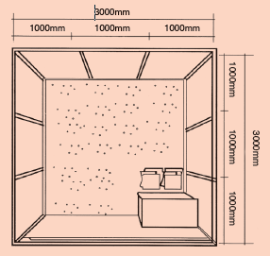
前视图 ELEVATION FRONT VIEW 3mL×3mW×2.5mH
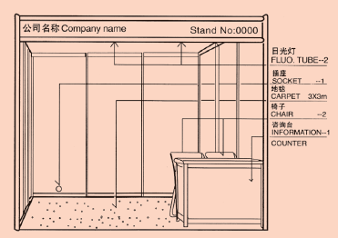

展馆平面图（一号馆一层）FLOOR PLAN（The 1st Floor of HALL１）
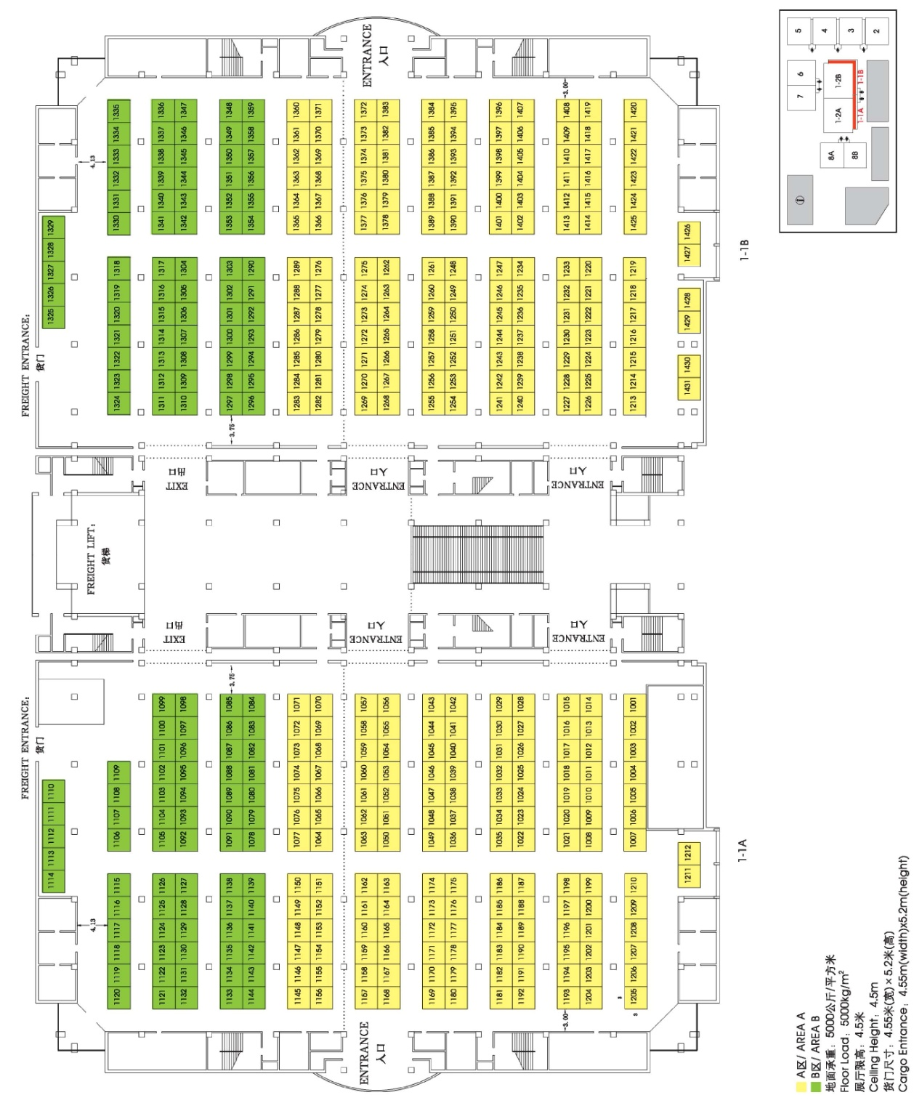

展馆平面图（一号馆二层）FLOOR PLAN（The 2nd Floor of HALL１）
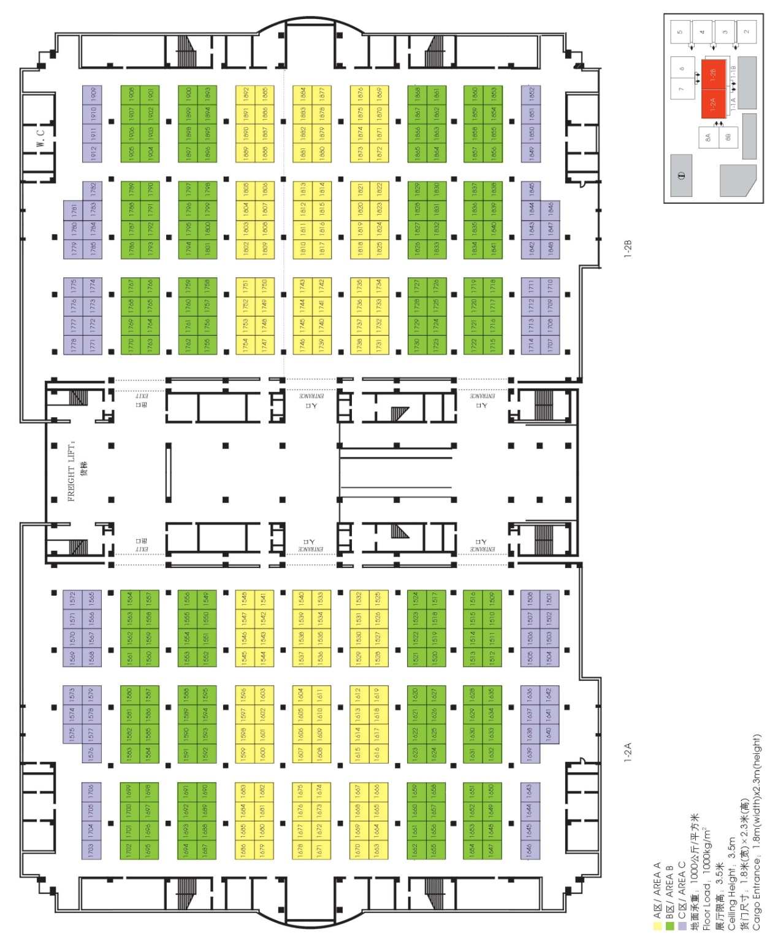

展馆平面图（二、三号馆）FLOOR PLAN（HALL2&3）
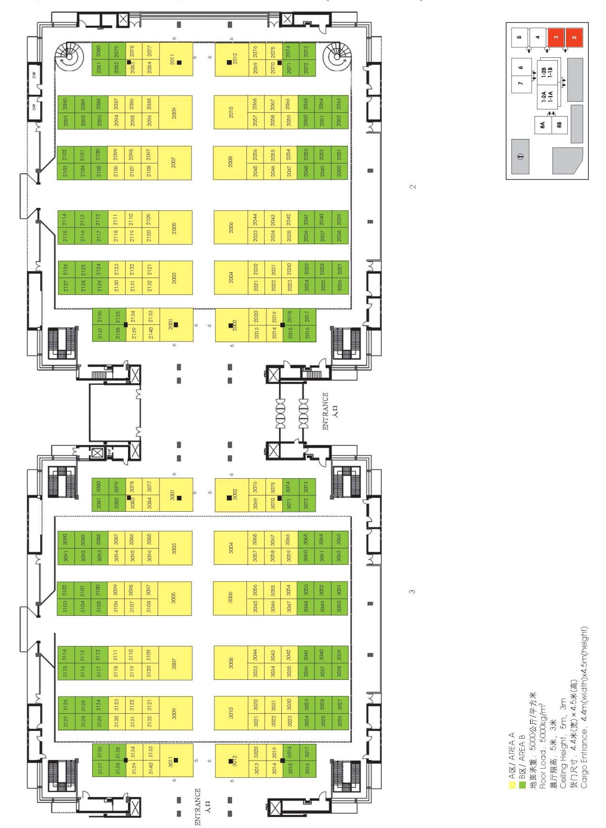

展馆平面图（四、五号馆）FLOOR PLAN（HALL 4&5）
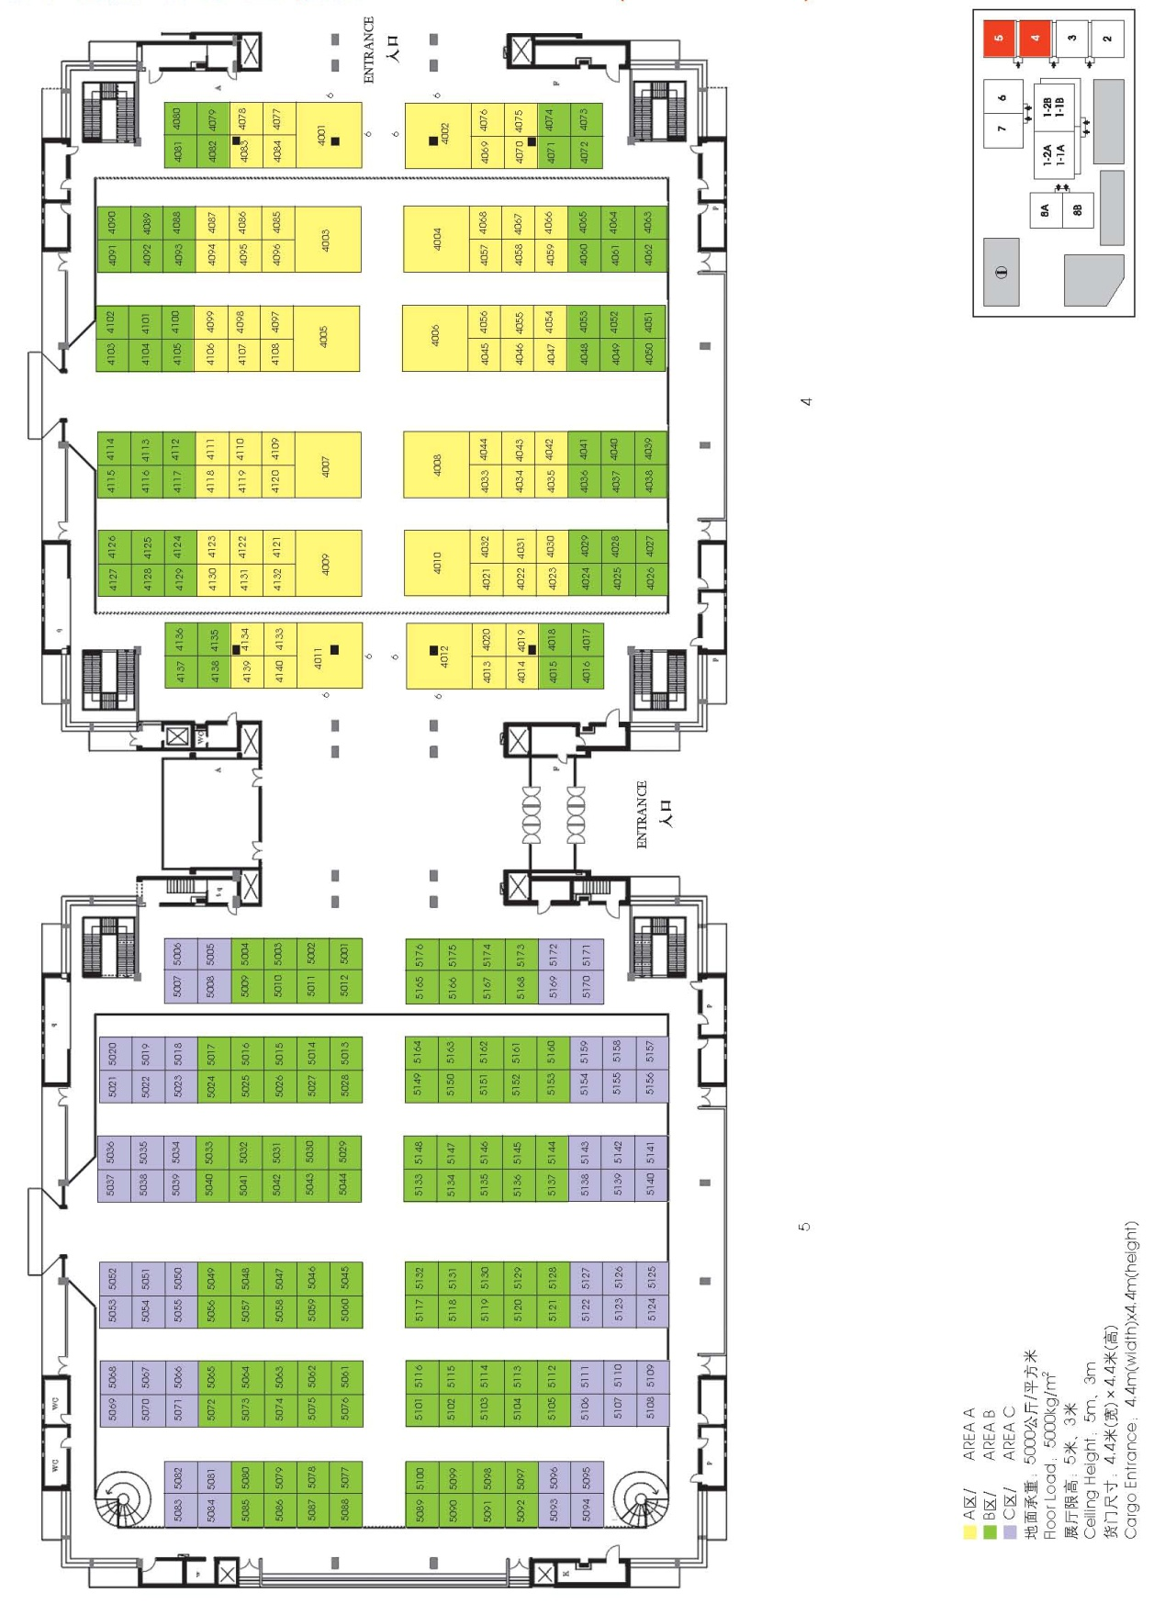

展馆平面图（六、七号馆）FLOOR PLAN（HALL 6&7）
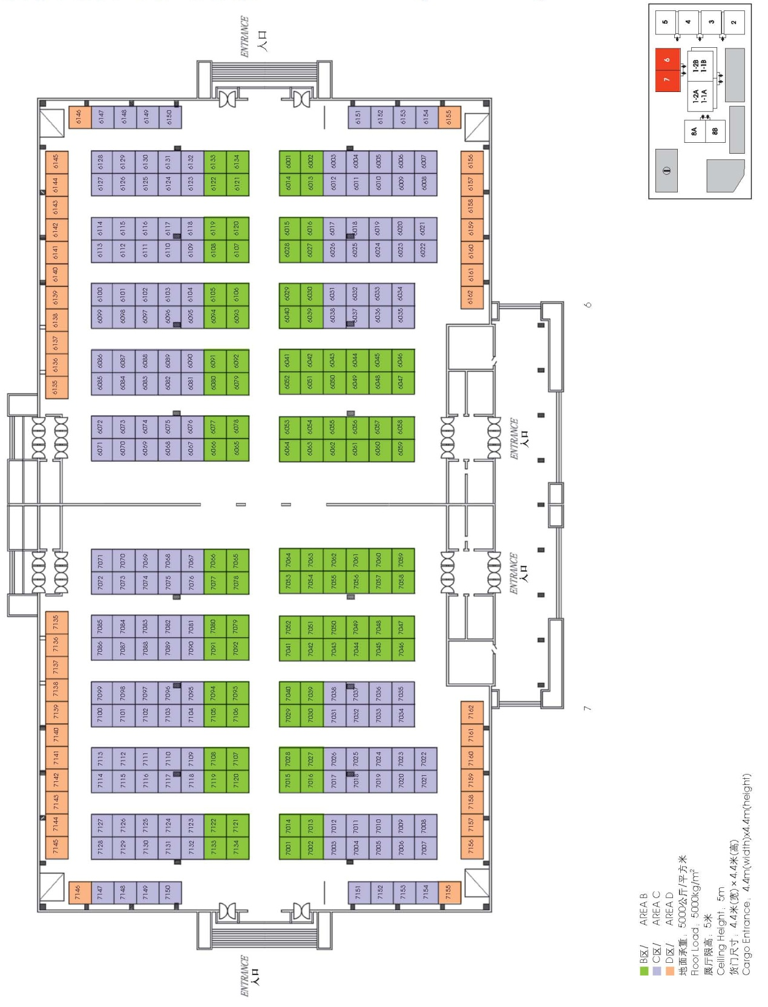

展馆平面图（八号馆）FLOOR PLAN（HALL 8）
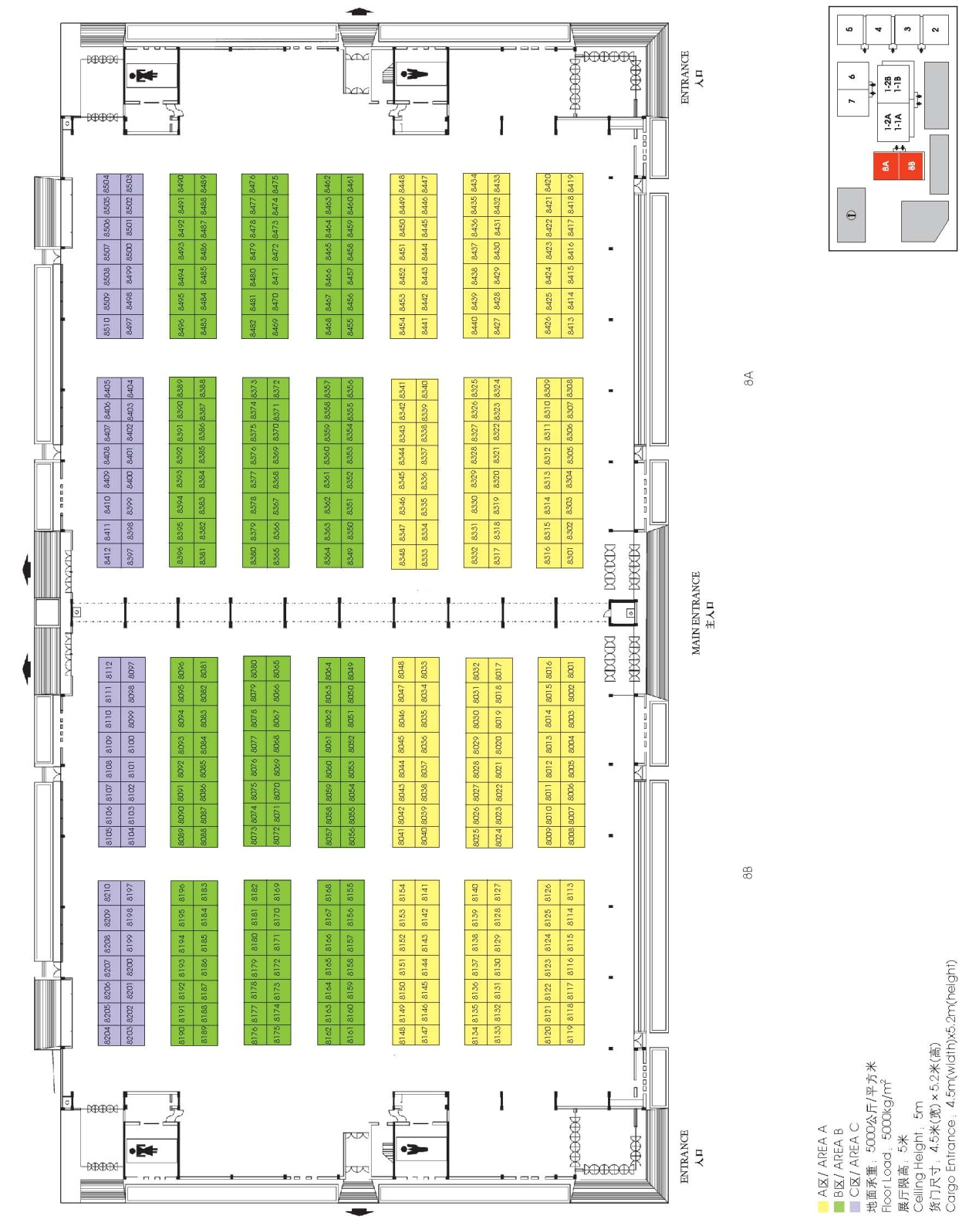

DEADLINE/ 截止日期：2013-10-10
参展申请表 APPLICATION FORM
COMPANY 公司名称 中文
ENGLISH
ADDRESS 地址 POSTCODE 邮编
TEL 电话 FAX 传真 CONTACT 联系人
E-MAIL 电子邮件 TITLE 职务
INTENDED EXHIBIT(S) 拟展展品
A - BOOTH REQUIREMENTS/展台预定
■INDOOR BOOTH PRICE/室内展位价格
AREA  区 域 | Shell Scheme Booth (3X3=9sq.m.)  标准展台（3米X3米＝9平方米） | RAW SPACE (Min. 36sq.m.)  光地展台（最小面积36平方米）
A区 | US$ 2,300.00 人民币¥16,000.00 | US$ 230.00/SQ.M. 人民币¥1,600.00/平方米
B区 | US$ 1,700.00 人民币¥12,000.00 | US$ 170.00/SQ.M. 人民币¥1,200.00/平方米
C区 | 人民币¥8,000.00 (Only for Demestic Exhibitors) | 人民币¥800.00/平方米 (Only for Demestic Exhibitors)
D区 | 人民币¥6,000.00 (Only for Demestic Exhibitors) | 人民币¥600.00/平方米 (Only for Demestic Exhibitors)
■OUTDOOR RAW SPACE PRICE(Min. 36sq.m.) 室外光地价格（最小36平方米）
for foreign exhibitor(s) US$100.00/SQ.M. | 国内参展商 人民币¥400.00/平方米
■BOOTH-TYPE & AREA OPTION / 展台类型和区域选择
TYPE/类型 □ SHELL SCHEME BOOTH/标准展台 □ RAW SPACE/光地展台
AREA/区域 □ A □ B □ C □ D □ OUT-DOOR/室外
PREFERRED DIMENSIONS/选择展台尺寸 WIDTH/宽 M/米 × DEPTH/深 M/米
PREFERRED STAND NO./选择展台号 1ST CHOICE/第一选择
2ND CHOICE/第二选择
3RD CHOICE/第三选择
■TOTAL SPACE/总面积 SQ.M./平方米
■RENTAL COST/展台费用 USD / 人民币

COMPANY CHOP & AUTHORIZED SIGNATURE FULL NAME & TITLE DATE
公司印章和负责人签字 负责人姓名和职务 日期
NOTE/注：We confirm that all information provided by us are true and correct. / 本公司证实所提供之全部信息资料属实无讹
PLEASE RETURN THIS FORM TO 请将此表寄回
World Trade Centre Beijing 北京世界贸易中心
Exhibition Dept. of the organizing committee office of ICCIE 文博会组委会办公室展览展示组
Attn: Ms. Liu Jie, Ms. Qi Wei, Mr. Wang Luocheng, Mr. Li Chao 刘洁、齐、王珞丞、李超
703 Yanshashengshi Building, No.23 Beisanhuan Middle Road, 地址：北京市西城区北三环中路23号燕莎盛世大厦703室
Xicheng District, Beijing 100029, China 邮编：100029
Tel: (86-10) 68066669-8022/8021/8012/8010 FAX: (86-10)68066969 电话：(010) 68066669-8022/8021/8012/8010
E-mail: lj@wtcbj.com, qw@wtcbj.com, wlc@wtcbj.com, lc@wtcbj.com 传真：(010) 68066969
Http://www.iccie.cn 邮箱：lj@wtcbj.com, qw@wtcbj.com, wlc@wtcbj.com,
lc@wtcbj.com 网址：www.iccie.cn

中国国际展览中心展馆分布图
LAYOUT OF CHINA INTERNATIONAL EXHIBITION CENTER
